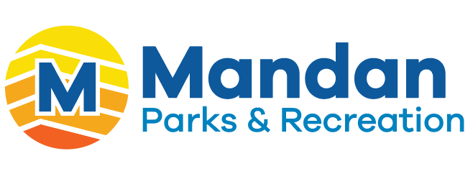

Mandan Parks and Recreation
is looking for a new team member

Facility Supervisor-Aquatics

The Mandan Park District is accepting applications for a full-time position of a Facility Supervisor. This position performs overall Supervision of Raging Rivers Waterpark, Mandan Aquatic Center and other duties as assigned by the Mandan Park District.

The attached job description details the Facility Supervisor-Aquatics, Job/Duties Responsibilities, Minimum Education and Experience requirements, Knowledge, Skills and Abilities requirements and other information.

An excellent compensation and benefits package is available.

If you are interested go to
www.mandanparks.com to complete an application
or call 701-751-6166

Complete application and submit resume and cover letter online, or you can send your cover letter and resume to:
Tyra Riepl
Mandan Park District
2600 46th Ave Se
Mandan, ND 58554
triepl@mandanparks.com

Closing date is March 26, 2025

Equal Opportunity Employer

