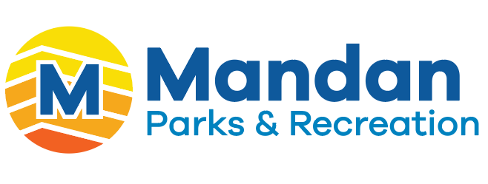

Mandan Parks and Recreation
is looking for a new FULL-TIME team member

STARION SPORTS COMPLEX MAINTENANCE WORKER

The Mandan Park District is accepting applications for a full-time Maintenance Worker at the Starion Sports Complex. This position is responsible for overall maintenance of the Sports Complex, including the hockey arena, football field, track, and general facility areas. Responsibilities include ice resurfacing, equipment operation, facility cleaning, snow removal, assisting with HVAC and compressor maintenance, and providing guidance to part-time and seasonal staff.

The attached job description details the Maintenance Worker Job/Duties Responsibilities, Minimum Education and Experience requirements, Knowledge, Skills and Abilities requirements and other information.

An excellent compensation and benefits package is available.

If you are interested go to
www.mandanparks.com to complete an application online
or call 701-751-6168

You can also send a cover letter and resume to:
Tyra Riepl
Mandan Park District
2600 46th Ave Se
Mandan, ND 58554
triepl@mandanparks.com

Closing date is March 27th, 2026

Equal Opportunity Employer

